**Git Vs GitHub:**

**GitHub:** It is repository to keep the code.

**Git:** It is version control

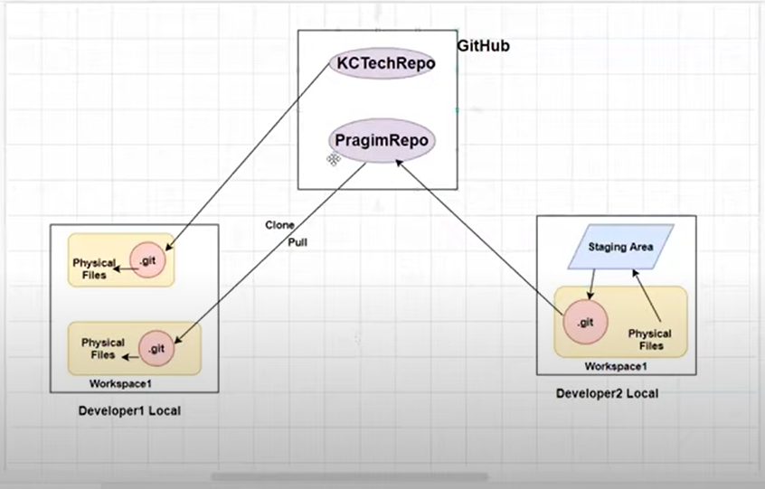

When we move code from local to GitHub, we can not move directly, first we have to move to **staging area(Commit)** from staging to GitHub(Push).

In staging area only Commit Id creating. We can see the commit id in Head file which is inside .git file.

To use git we have to download and install git for windows.

**Commands:**

**Clone:** This is used in first time it will copy the

*Git clone <url of repository>*

**Git add:** Add the file in queue to staging area.

*Git add <file name>* add only one file

*Git add --all*  add all the file

*Git add .* add all the file in the current directory

*Git add <file name1>, <file1>*

**Git reset HEAD <>:** Remove the file queue, it should done before commit

*Git reset HEAD <file name>*

**Git Status:** This is used to show the file status which are modified and add newly in local

*git status*

**Git commit:** It will move the file form physical memory to staging which in queue

*Git commit -m “commit message”*

**Git Push:** Move the file to GitHub

*Git push origin <branch name>*

**List:** List the files

*Ls*

**Cat:** It will show the content the file

*Cat <filename>*

**Create new branch:**

*Git branch <brachname>*

**Git init:** It is used to initiate the git local directory. We can map the local directory to GitHub later. Just it will create .git file in local directory.

*Git init*

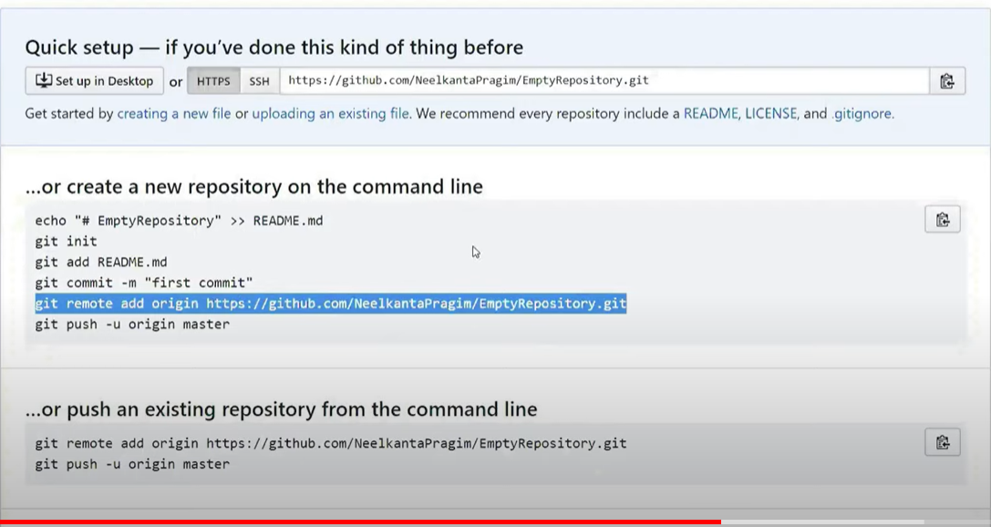

Here is Origin is alias name of GitHub.

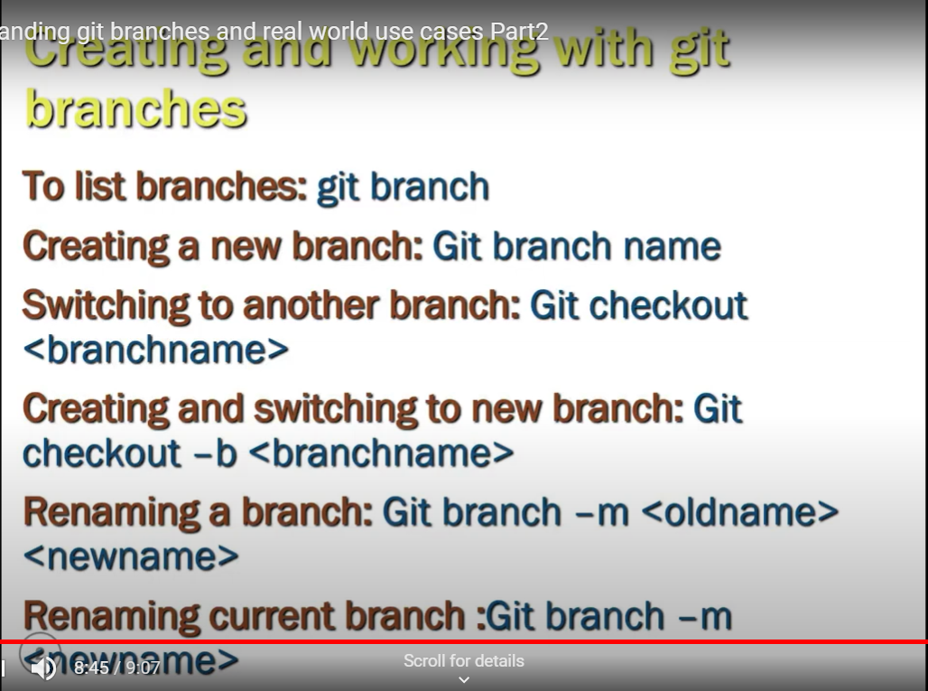

**Create new branch local git and Push to GitHub remote:**

*Git push origin <createdNewbranch Name_locally>*

Note:

We can not push to GitHub directly, we have commit before.

**Pull:**

Pull and clone both are used to copy the file from GitHub repository to local. But Clone used in first time. We can use Pull any time.

*Git pull*

**Merge:** Used to merge two branches

*Git merge <Master>*ex: I am in dev branch, merge changes to master branch.